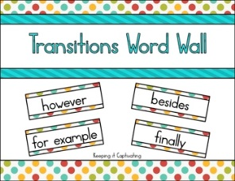
Transition Words

►To introduce an example:

especially in this case take the case of
for example one example of this is to demonstrate
for instance on this occasion to illustrate
frequently specifically

►To show agreement:
of course admittedly it is true that
certainly no doubt

►To introduce an additional idea:

additionally as well as in addition
again besides moreover
also equally important one could also say
and finally nor
and then further not to mention
another furthermore

►To indicate sequence or order, or logically divide an idea:

after eventually previously
afterwards finally second
and then first simultaneously
at this point followed by subsequently
at this time last third
before, meanwhile ultimately
concurrently next
►To indicate time:

after, earlier previously
afterwards finally prior to
at this point formerly soon
at this time immediately then
before initially thereafter
during later to this day

►To compare:

another way to view this just like similarly
balanced against likewise whereas
by comparison like while

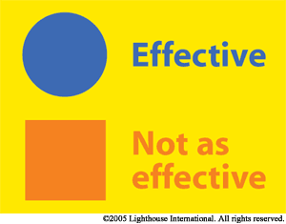

►To contrast:

a different view is even so nevertheless
and however notwithstanding
balanced against in contrast still
but on the contrary unlike
conversely on the other hand yet
differing from
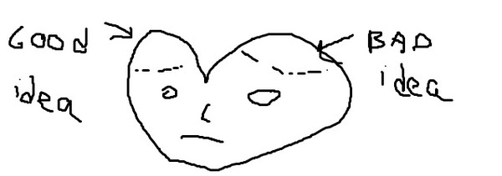

►To introduce an opposite idea or show exception:

alternatively in contrast on the other hand
but in spite of still
despite instead whereas
even though nevertheless while
however one could also say yet

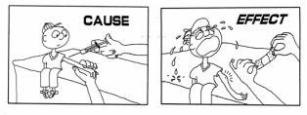
►To show cause and effect:

and so consequently therefore
as a consequence for this reason thus
as a result hence

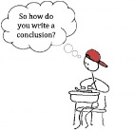

►To summarise or conclude:

as a result in conclusion therefore
as shown in other words thus
consequently in summary to conclude
finally on the whole to summarise
hence summing up ultimately
in brief

